Large-scale forecasting of large fluctuations using wavelet coherence and multifractal behavior and developing wavelet coherence for multiple time series

Tunc Oygur^{1,} *, Yaman Ömer Erzurumlu², Gazanfer Unal³

¹ Financial Economics Programme, School of Social Science, Yeditepe University, Istanbul, 34755, Turkey
² Engineering Management, Bahcesehir University, Istanbul, 34353, Turkey
³Administrative and Social Sciences, Bahcesehir University, Istanbul, 34353, Turkey

* Correspondence:
Tunc Oygur
E-mail: tunc.oygur@std.yeditepe.edu.tr

This article is derived from the first author’s Ph.D. dissertation entitled “Large-scale forecasting of large fluctuations using wavelet coherence and multifractal behavior and developing wavelet coherence for multiple time series,” conducted under the supervision of the second author.
Abstract
Shocks, jumps, booms, and busts are typical large fluctuation markers that appear in crisis. Identifying financial crises and estimating leading indicators with strong relations during crisis periods have an essential role in the literature. This thesis examines the dynamic co-movements of leading indicators' multifractal features to identify financial crises due to large fluctuations. The detected dynamic relationships predict leading indicators with scale-by-scale analysis and make large-scale predictions better than challenger models. As a natural result of these studies, the n-dimensional wavelet coherence method is examined, and the vectorwavelet package is transferred to the R program. This thesis consists of three independent parts, and the contents of the studies are summarized below. In the first part, stock returns' co-movements with other leading indicators in crisis periods are analyzed with multiple and quadruple wavelet coherence using interest rate, exchange rate, and trade balance differences. The scale-by-scale wavelet transformation was used to predict large-scale relationships, and stock return estimation was performed. In the second part, the multifractal characteristics of sectoral default probabilities of the real sector in Turkey and Turkey sovereign CDS rates were examined by detrended fluctuation analysis. Significant dynamic connections between the Hölder exponents of the default rates and CDS during financial crisis periods have been examined. During the periods of financial crises, among the Hölder exponents, severely correlated large scales show multifractal features. Scale-by-scale wavelet transform has been used to predict large-scale relationships, and hence vector fractionally autoregressive integrated moving average forecasting provides better results than scalar models. The final part of the thesis introduces a new wavelet methodology to handle multivariate time series dynamic co-movements by extending multiple quadruple wavelet coherence methodologies. The primary motivation of our works is to measure wavelet coherence analytically for the specific dimension.
Keywords: Financial crises; large fluctuations, large-scale forecast, multiscale analysis, vector wavelet coherence

INTRODUCTION
Financial crises cannot often be explained by one factor; they have common elements and arise in various forms. Ordinarily, financial crises deal with one or more of the chasing events: asset price booms and busts, credit booms and busts, and the impact of asset price and credit busts. Financial crises are distinguished into two types of crises, which are determined using qualitative methods (currency and sudden stop crises) and judgmental analysis (foreign and domestic debt and banking crises) by Reinhart and Rogoff (Reinhart & Rogoff, 2009). Many empirical models exist in the literature, and explanatory variables exist to predict crises and have evolved over time.
One of these methods is analyzing stock return, exchange rate, and interest rate movements. In the following, researchers found that exchange rates and stock price co-movement has revealed a strong relationship between the two variables, especially during the crisis period ( (Katechos, 2011), (Lin, 2012), (Tsai, 2012), (Walid, Chaker, Masood, & Fry, 2011)). Analyzing the long-term relationship between two variables, the instability or lack of relationship can be offered ( (Diamandis & Drakos, 2011), (Nath & Samanta, 2003), (Phylaktis & Ravazzolo, 2005), (Zhao, 2010), (Choi & Park, 2008)) demonstrates that he stabilized high-interest rates during the currency crises. For this reason, the exchange rate and/or interest rate shocks impress the stock returns ( (Ahmad, Ahmad, & Rehman, 2010), (Pirovano, 2012), (Ioannidis & Kontonikas, 2008)). Few researchers consider the joint movement of stock prices, exchange rates, and interest rates, unlike others ( (Andries, Alin Marius; Ihnatov, Iulian; Tiwari, Aviral Kumar, 2014), (Gupta, Chevalier, Sayekt, & others, 2001), (Hamrita & Trifi, 2011), (Mok, 1993)). The first study’s main objective is to investigate the structure of the dynamic correlation of stock return, exchange rate, interest rate, and trade balance differences in crisis periods using wavelet coherency analysis.
Furthermore, various studies in the literature explore the derivative financial instrument called credit default swap (CDS) and stock exchange relations during crisis periods. CDS is one of the successful financial invitations of the last few years due to its use as a risk perception indicator by analysts, governments, and decision-makers (Asandului, Mircea; Lupu, Dan; Claudiu, Gabriel; Musetescu, Radu, 2015). From local or regional events to global events, they can influence by many various factors. Therefore, sovereign CDS is used to establish a connection between financial crises and sectoral default probabilities. The second study’s main objective is to investigate the co-movement of the real sector default probabilities and CDS in crisis periods using wavelet coherency analysis.
MATERIALS and METHODS
This study consists of three independent parts. For this reason, materials and methods are mentioned separately.
Chapter 1
The first part of the study analyzes stock returns’ co-movements with other leading indicators in crisis periods with multiple and quadruple wavelet coherence using Turkey’s interest rate, exchange rate, and trade balance differences. The data are collected monthly from October 1990 to March 2015, which is 294 observations. All the series are expressed as log-difference returns and expressed as: $R_{t}=100×ln(P_{t}/P_{t-1})$; where $R_{t}$ is the return in percent and $P_{t}$ and $P_{t-1}$ denote the closing price on time $t$ and $t-1$, respectively.
Firstly, preliminary analyses are done for all variables to illustrate series characteristics. Considering preliminary analysis flowing tests are evaluated: normality, autocorrelation, stationary, heteroscedasticity, and correlation between variables. The continuous wavelet transform (CWT) analysis is applied for univariate analysis to better view for crisis period. Next, the cross-wavelet (XWT) and wavelet coherence (WTC) analyses are employed to understand the dynamic co-movement between series. In addition, multiple (MWC) and quadruple (QWC) wavelet coherence analyses are used to understand high dimensional relationships. Finally, the scale-by-scale forecasting procedure is proposed, and selected crisis regions in quadruple wavelet coherence are used for the forecasting.

Chapter 2
The second part examined the multifractal characteristics of sectoral default probabilities of the real sector in Turkey and Turkey’s sovereign CDS rates by detrended fluctuation analysis. The data sources are divided into two parts, and the data covers the period between January 2001 and March 2018. The first is the real sector firm’s quarterly balance sheet data in BIST 100, and the second one is weekly basis market data which are stock price, interest rate, and CDS rates. The data are collected from Thomson Reuters data services, and 900 observations exist.
In the first part, real sector default probabilities are calculated using Moody’s KMV expected default frequency methodology. The Reuters sector descriptions are considered to evaluate sectoral default probabilities. The main sectors are Consumer Cyclicals, Industrials, Basic Materials, Consumer Non-Cyclicals, and Utilities. The second part investigates the univariate characteristics of the sectoral default probabilities and CDS series called preliminary analysis. This section mainly focuses on stationarity and fractality; both stationarity tests, which are ADF, PP, KPSS, and PSR, and the Hurst exponents in different methods, are evaluated. The third section examines univariate and bivariate multifractal characteristics, and q-order Hurst exponent and local-pointwise Hölder exponents are calculated. For this reason, comprehensive multifractal studies are employed, consisting of multifractal detrended fluctuation analysis, detrended cross-correlation analysis, and detrended moving average cross-correlation analysis. The following section examines dynamic co-movement using wavelet coherence between different types of Hölder exponents of the sectorial PDs and CDS rates. Finally, the scale-by-scale forecasting procedure is proposed and selected crisis regions in local Hölder exponents wavelet coherence are used for the forecasting.
Chapter 3
The final part of the study introduces a new wavelet methodology to handle multivariate time series dynamic co-movements by extending multiple and quadruple wavelet coherence methodologies.
The squared n-dimensional vector wavelet coherency between series $y$ and other series $x_{1}$, $x_{2}$, ..., $x_{n}$ will be denoted by $VR_{y(x_{1}x_{2},...,x_{n})}^{2}$ (or $VR_{y(q)}^{2}$ and is given by the formula,
$$\begin{matrix}VR_{y(q)}^{2}=VR_{1(23...n)}^{2}=1-\frac{M^{d}}{S_{11}M_{11}^{d}},\end{matrix}$$ | (1)
where $M$ denotes the $n×n$ matrix of the all the smoothed cross-wavelet spectra $S_{ij}$ which is the smoothed version of $W_{ij}$. Moreover, where $S$ is a certain smoothing operator.
Corresponding to the matrix $M$, we now consider the matrix $C$ of all the smoothed complex wavelet coherencies $ρ_{ij}$, i.e.
$$\begin{matrix}C=\left[\begin{matrix}1 & ρ_{12} & ρ_{13} & ... & ρ_{1n} \\ ρ_{21} & 1 & ρ_{23} & ... & ρ_{2n} \\ ρ_{31} & ρ_{32} & 1 & ... & ρ_{3n} \\ ... & ... & ... & ... & ... \\ ρ_{n1} & ρ_{n2} & ρ_{n3} & ... & 1\end{matrix}\right],\end{matrix}$$ | (2)
Note that $ρ_{jj}=\frac{S(W_{jj})}{\sqrt{S\left({\left|W_{j}\right|}^{2}\right) S\left({\left|W_{j}\right|}^{2}\right) }}=1$ As $M$, the matrix $C$ is also a Hermitian matrix, i.e. $ρ_{ij}=ρ_{ji}^{*}$.
Then, we can define the n-dimensional vector coherence by the following formula:
$$\begin{matrix}VR_{1(q)}^{2}=1-\frac{C^{d}}{C_{11}^{d}}.\end{matrix}$$ | (3)

RESULTS
The Results for Research Question 1
According to the lead-lag relationship, the results of XWT and WTC support together for the 1994 currency crisis. Nevertheless, for the 2001 banking crisis, phase difference results are different. According to Andries et al. (2014) (Andries, Alin Marius; Ihnatov, Iulian; Tiwari, Aviral Kumar, 2014), “cross wavelet describes the common power of two processes without normalization to the single wavelet power spectrum. This can produce misleading results because one essentially multiplies the continuous wavelet transform of two time series.” Because of this, we consider wavelet coherence results.
Table 1 demonstrates that these two crises have structural differences. In the 1994 currency crisis, fluctuations in currency may affect stock, interest rate, and trade balance returns. Unlike the 1994 currency crisis, the 2001 banking crisis was based on interest rate fluctuations and affected Turkey’s whole banking system. Phase difference results confirm this information. These results indicate that macroeconomic fluctuations often appear in crisis periods, as stock and interest rate return fluctuations occurred in Turkey’s crises and provide us information about the reasons for the occurrence of crises.
The Results for Research Question 2
The q-order Hurst, pointwise, and local Hölder exponents are used to define the time series’ fragilities to determine the links between CDS and sectors. In this view, dynamic co-movements between the series are determined by wavelet coherence, taking into account the fragility, trend, and structural changes. The results are presented in Figure 1. The results indicate that CDS explains sectoral default probabilities in many time-frequency domains. As a result of the theoretical and fundamental contrasts between the exponents, the local Hölder exponent is selected to analyze crisis periods. However, according to local Hölder exponents, the co-movement of the CDS and PDs reveals all the financial crises in the analysis period. Another significant finding also discusses the lead-lag relationship: the sectoral default probability is the leading indicator of catching the financial crisis.
The Results for Research Question 3
This study suggests a new econophysics tool, the vector wavelet coherence, that may be useful in investigating dynamic co-movements of multivariate time series. The vector wavelet coherence is defined as the n-dimensional extension of wavelet coherence, multiple wavelet coherence, and quadruple wavelet coherence. Vectorwavelet (Oygur, Tunc; Unal, Gazanfer, 2020) R computer packages facilitate the computations of vector wavelet coherence.
DISCUSSION and CONCLUSION
Chapter 1
The multiple wavelet coherence and quadruple (Figure 2) wavelet coherence demonstrate that stock returns are explained by exchange rate, interest rate, and trade balance returns in the most time-frequency domain. This finding allows us to analyze stock returns scale by scale and strongly correlated large scales indicating linear behavior. For this reason, we applied multivariate and univariate time series methodologies for predicting stock returns in selected regions. VARMA(1,1) model appears to be the most appropriate model according to forecast performances.
Chapter 2
The CDS versus Consumer Cyclical, Basic Materials, and Utility sectors have been used for large-scale forecasts in the 2008 US subprime mortgage crisis period with the low-frequency determined relations. The scale-by-scale analysis is performed on these views to create panes from local Hölder exponents. Then, we employed multivariate and univariate time series methodologies for 12-step- ahead (three months) prediction of the local Hölder exponents in chosen regions. The vector-type models perform better for modeling the macroeconomic series. Because the series show multifractal characteristics, the vectoral autoregressive fractionally integrated moving average model (VFARIMA) is established to be better than the benchmark models, which are FARIMA, VARMA, and ARMA in all selected windows.

REFERENCES
Abry, Patrice; Goncalves, Paolo; Véhel, Jacques Lévy. (2013). Scaling, fractals and wavelets. John Wiley & Sons.
Aguiar-Conraria, L., Azevedo, N., & Soares, M. J. (2008). Using wavelets to decompose the time–frequency effects of monetary policy. Physica A: Statistical mechanics and its Applications, 387, 2863–2878.
Aguiar-Conraria, Luı́s; Soares, Maria Joana. (2011). Oil and the macroeconomy: using wavelets to analyze old issues. Empirical Economics, 40, 645–655.
Ahmad, M. A., Ahmad, R. U., & Rehman, A. R. (2010). Do interest rate, exchange rates effect stock returns? A Pakistani Perspective, International Research Journal of Finance and Economics, 50, 146–150.
Andries, Alin Marius; Ihnatov, Iulian; Tiwari, Aviral Kumar. (2014). Analyzing time–frequency relationship between interest rate, stock price and exchange rate through continuous wavelet. Economic Modelling, 41, 227–238.
Arianos, Sergio; Carbone, Anna. (2007). Detrending moving average algorithm: A closed-form approximation of the scaling law. Physica A: Statistical Mechanics and its Applications, 382, 9-15. doi:https://doi.org/10.1016/j.physa.2007.02.074
Asandului, Mircea; Lupu, Dan; Claudiu, Gabriel; Musetescu, Radu. (2015). DYNAMIC RELATIONS BETWEEN CDS AND STOCK MARKETS IN EASTERN EUROPEAN COUNTRIES. Economic Computation & Economic Cybernetics Studies & Research, 49, 151–170.
Bharath, Sreedhar T.; Shumway, Tyler. (2004). Forecasting default with the KMV-Merton model. This article is available in SSRN.
Choi, I., & Park, D. (2008). Causal relation between interest and exchange rates in the Asian currency crisis. Japan and the World Economy, 20, 435–452.
Chung, Ching-Fan. (2001). Calculating and analyzing impulse responses for the vector ARFIMA model. Economics Letters, 71, 17–25.
Cumhur, T. A. Ş.; Ünal, Dr Gazanfer. (2013). MULTIFRACTAL BEHAVIOUR IN NATURAL GAS PRICES BY USING MF-DFA AND WTMM METHODS. International Journal of Economics and Finance Studies, 5, 44–55.
Diamandis, P. F., & Drakos, A. A. (2011). Financial liberalization, exchange rates and stock prices: Exogenous shocks in four Latin America countries. Journal of Policy Modeling, 33, 381–394.
Fernández-Macho, Javier. (2012). Wavelet multiple correlation and cross-correlation: A multiscale analysis of Eurozone stock markets. Physica A: Statistical Mechanics and its Applications, 391, 1097–1104. doi:10.1016/j.physa.2011.11.002
Fernández-Macho, Javier. (2018). Time-localized wavelet multiple regression and correlation. Physica A: Statistical Mechanics and its Applications, 492, 1226–1238. doi:10.1016/j.physa.2017.11.050
Fernández-Macho, Javier. (2018). wavemulcor: Wavelet Routines for Global and Local Multiple Correlation. R package.
Grinsted, A., Moore, J. C., & Jevrejeva, S. (2004). Application of the cross wavelet transform and wavelet coherence to geophysical time series. Nonlinear processes in geophysics, 11, 561–566.
Gülerce, M., & Ünal, G. (2016). Using wavelet analysis to uncover the co-movement behavior of multiple energy commodity prices. International Journal of Wavelets, Multiresolution and Information Processing, 14, 1650047.
Gülerce, Mustafa; Ünal, Gazanfer. (2018). Electricity price forecasting using multiple wavelet coherence method: Comparison of ARMA versus VARMA. International Journal of Financial Engineering, 5, 1850004. doi:10.1142/S2424786318500044
Gupta, J. P., Chevalier, A., Sayekt, F., & others. (2001). The Causality between interest rate, exchange rate and stock price in emerging markets: The case of the Jakarta Stock Exchange. Fuzzy Sets in Management, Economics, and Marketing, 145.
Hamrita, M. E., & Trifi, A. (2011). The relationship between interest rate, exchange rate and stock price: A wavelet analysis. International Journal of Economics and Financial Issues, 1, 220.
Hansen, Peter R.; Lunde, Asger; Nason, James M. (2011). The Model Confidence Set. Econometrica, 79, 453-497. doi:10.3982/ECTA5771
Ihlen, E. A. (2012). Introduction to multifractal detrended fluctuation analysis in Matlab. Frontiers in physiology, 3, 141.
Ioannidis, C., & Kontonikas, A. (2008). The impact of monetary policy on stock prices. Journal of Policy Modeling, 30, 33–53.
Jiang, Zhi-Qiang; Zhou, Wei-Xing. (2011, 7). Multifractal detrending moving-average cross-correlation analysis. Phys. Rev. E, 84(1), 016106. doi:10.1103/PhysRevE.84.016106
Kahraman, E., & Ünal, G. (2016). Multiple Wavelet Coherency Analysis and Forecasting of Metal Prices. arXiv preprint arXiv:1602.01960.
Kantelhardt, Jan W.; Zschiegner, Stephan A.; Koscielny-Bunde, Eva; Havlin, Shlomo; Bunde, Armin; Stanley, H. Eugene. (2002). Multifractal detrended fluctuation analysis of nonstationary time series. Physica A: Statistical Mechanics and its Applications, 316, 87–114.
Katechos, G. (2011). On the relationship between exchange rates and equity returns: A new approach. Journal of International Financial Markets, Institutions and Money, 21, 550–559.
Kuperin, Y. A., & Morozova, M. M. (2010, 8). Statistical and Multifractal Properties of the Time Series Generated by a Modified Minority Game. Papers, arXiv.org. Retrieved from https://arxiv.org/abs/1008.3840
Kuperin, Yu A.; Schastlivtsev, R. R. (2008, 2). Multifractal Analysis and Local Hoelder Exponents Approach to Detecting Stock Markets Crashes. Papers, arXiv.org. Retrieved from https://arxiv.org/abs/0802.4460
Lin, C.-H. (2012). The co-movement between exchange rates and stock prices in the Asian emerging markets. International Review of Economics & Finance, 22, 161–172.
Lütkepohl, H., & Poskitt, D. S. (1996). Specification of echelon-form VARMA models. Journal of Business & Economic Statistics, 14, 69–79.
Mandelbrot, B. B. (1997). The variation of certain speculative prices. In Fractals and scaling in finance (pp. 371–418). Springer.
Maraun, D., & Kurths, J. (2004). Cross wavelet analysis: significance testing and pitfalls. Nonlinear Processes in Geophysics, 11, 505–514.
Matia, Kaushik; Ashkenazy, Yosef; Stanley, H. Eugene. (2003). Multifractal properties of price fluctuations of stocks and commodities. EPL (Europhysics Letters), 61, 422.
Mihanović, H., Orlić, M., & Pasarić, Z. (2009). Diurnal thermocline oscillations driven by tidal flow around an island in the Middle Adriatic. Journal of Marine Systems, 78, S157–S168.
Mok, H. M. (1993). Causality of interest rate, exchange rate and stock prices at stock market open and close in Hong Kong. Asia Pacific Journal of Management, 10, 123–143.
Nath, G. C., & Samanta, G. P. (2003). Relationship between Exchange Rate and Stock Prices in India-An Empirical Analysis. Available at SSRN 475823.
Ng, E. K., & Chan, J. C. (2012). Geophysical applications of partial wavelet coherence and multiple wavelet coherence. Journal of Atmospheric and Oceanic Technology, 29, 1845–1853.
Oygur, Tunc; Unal, Gazanfer. (2017). Evidence of Large Fluctuations of Stock Return and Financial Crises from Turkey: Using Wavelet Coherency and Varma Modeling to Forecast Stock Return. Fluctuation and Noise Letters, 16, 1750020. doi:10.1142/S0219477517500201
Oygur, Tunc; Unal, Gazanfer. (2020). Traces of the Multifractal Nature of the Financial Crises in Turkey: Co-Movement of the Hölder Exponents and Large-Scale Forecast. Fluctuation and Noise Letters, 2050029. doi:10.1142/S0219477520500297
Peters, Edgar E.; Peters, Donada. (1994). Fractal market analysis: applying chaos theory to investment and economics (Vol. 24). John Wiley & Sons.
Phylaktis, K., & Ravazzolo, F. (2005). Stock prices and exchange rate dynamics. Journal of International Money and Finance, 24, 1031–1053.
Pirovano, M. (2012). Monetary policy and stock prices in small open economies: Empirical evidence for the new EU member states. Economic Systems, 36, 372–390.
Podobnik, B., Grosse, I., Horvatić, D., Ilic, S., Ivanov, P. C., & Stanley, H. E. (2009). Quantifying cross-correlations using local and global detrending approaches. The European Physical Journal B, 71, 243. doi:"https://doi.org/10.1140/epjb/e2009-00310-5"
Reinhart, C. M., & Rogoff, K. S. (2009). This time is different: eight centuries of financial folly. princeton university press.
Simionescu, M. (2014). The accuracy assessment of macroeconomic forecasts based on econometric models for Romania. Procedia Economics and Finance, 8, 671–677.
Tang, Junjun; Wang, Jing; Huang, Cheng; Wang, Guolun; Wang, Xiong. (2008). Subprime mortgage crisis detection in US foreign exchange rate market by multifractal analysis. Young Computer Scientists, 2008. ICYCS 2008. The 9th International Conference for, (pp. 2999–3004).
Torrence, C., & Webster, P. J. (1999). Interdecadal changes in the ENSO-monsoon system. Journal of Climate, 12, 2679–2690.
Torrence, Christopher; Compo, Gilbert P. (1998). A practical guide to wavelet analysis. Bulletin of the American Meteorological society, 79, 61–78.
Tsai, I.-C. (2012). The relationship between stock price index and exchange rate in Asian markets: A quantile regression approach. Journal of International Financial Markets, Institutions and Money, 22, 609–621.
Tsay, R. S. (2013). Multivariate time series analysis: with R and financial applications. John Wiley & Sons.
Véhel, J. L., & Legrand, P. (2004). Signal and Image processing with FracLab. In Thinking in Patterns (pp. 321–322). World Scientific.
Walid, C., Chaker, A., Masood, O., & Fry, J. (2011). Stock market volatility and exchange rates in emerging countries: A Markov-state switching approach. Emerging Markets Review, 12, 272–292.
Wang, Yudong; Wei, Yu; Wu, Chongfeng. (2010). Cross-correlations between Chinese A-share and B-share markets. Physica A: Statistical Mechanics and its Applications, 389, 5468-5478. doi:https://doi.org/10.1016/j.physa.2010.08.029
Zhang, W., Wang, P., Li, X., & Shen, D. (2018). Quantifying the cross-correlations between online searches and Bitcoin market. Physica A: Statistical Mechanics and its Applications, 509, 657-672. doi:10.1016/j.physa.2018.06.0
Zhao, H. (2010). Dynamic relationship between exchange rate and stock price: Evidence from China. Research in International Business and Finance, 24, 103–112.
Zhou, Wei-Xing. (2008, 6). Multifractal detrended cross-correlation analysis for two nonstationary signals. Phys. Rev. E, 77(6), 066211. doi:10.1103/PhysRevE.77.066211

TABLES
Table 1. Phase difference results.
 | 1994 |  | 2001
 | XTC | WCT | XTC | WTC
S & Ex | leading | leading | leading | lagging
S & Int | lagging | lagging | lagging | leading
S & T | lagging | lagging | lagging | lagging
Ex & In | lagging | lagging | leading | lagging

FIGURES
Figure 1. The wavelet coherences of all series.
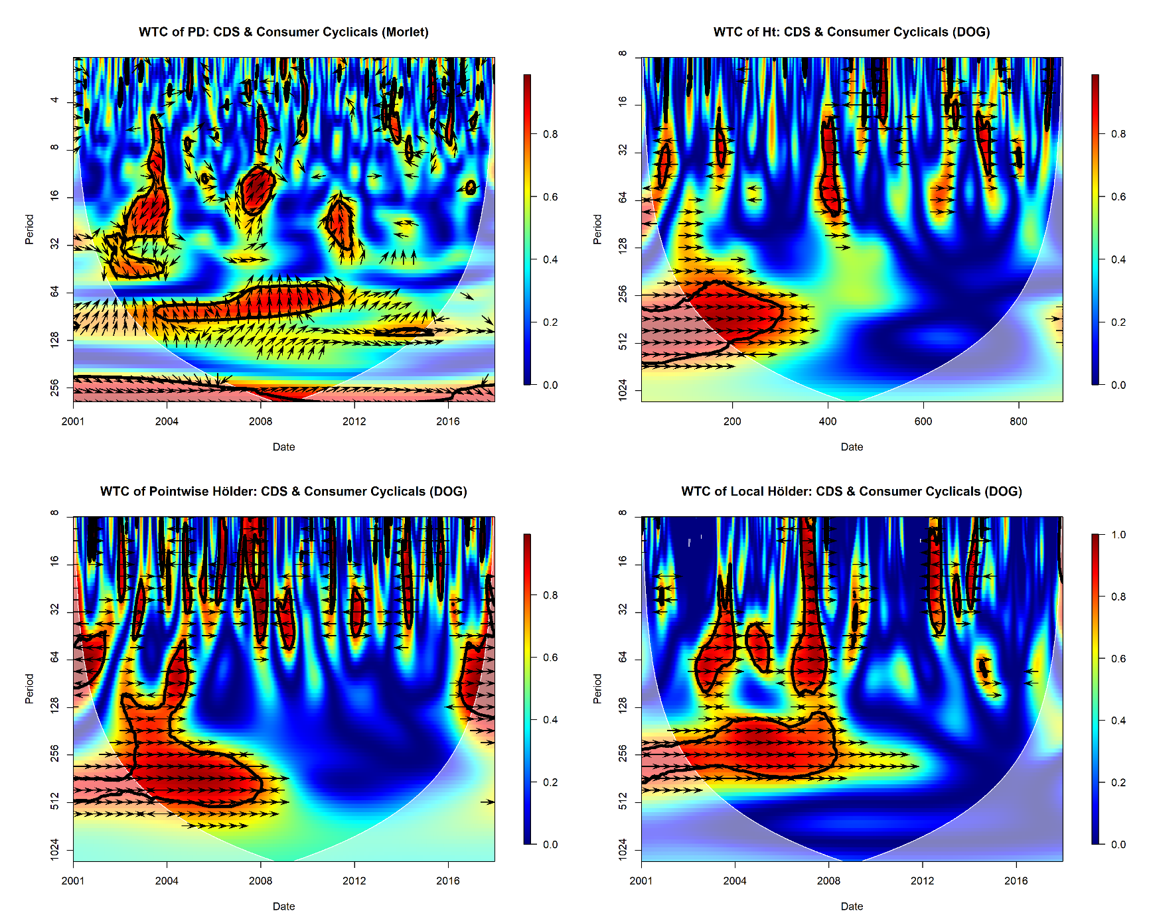
- WTC: CDS versus Consumer Cyclicals
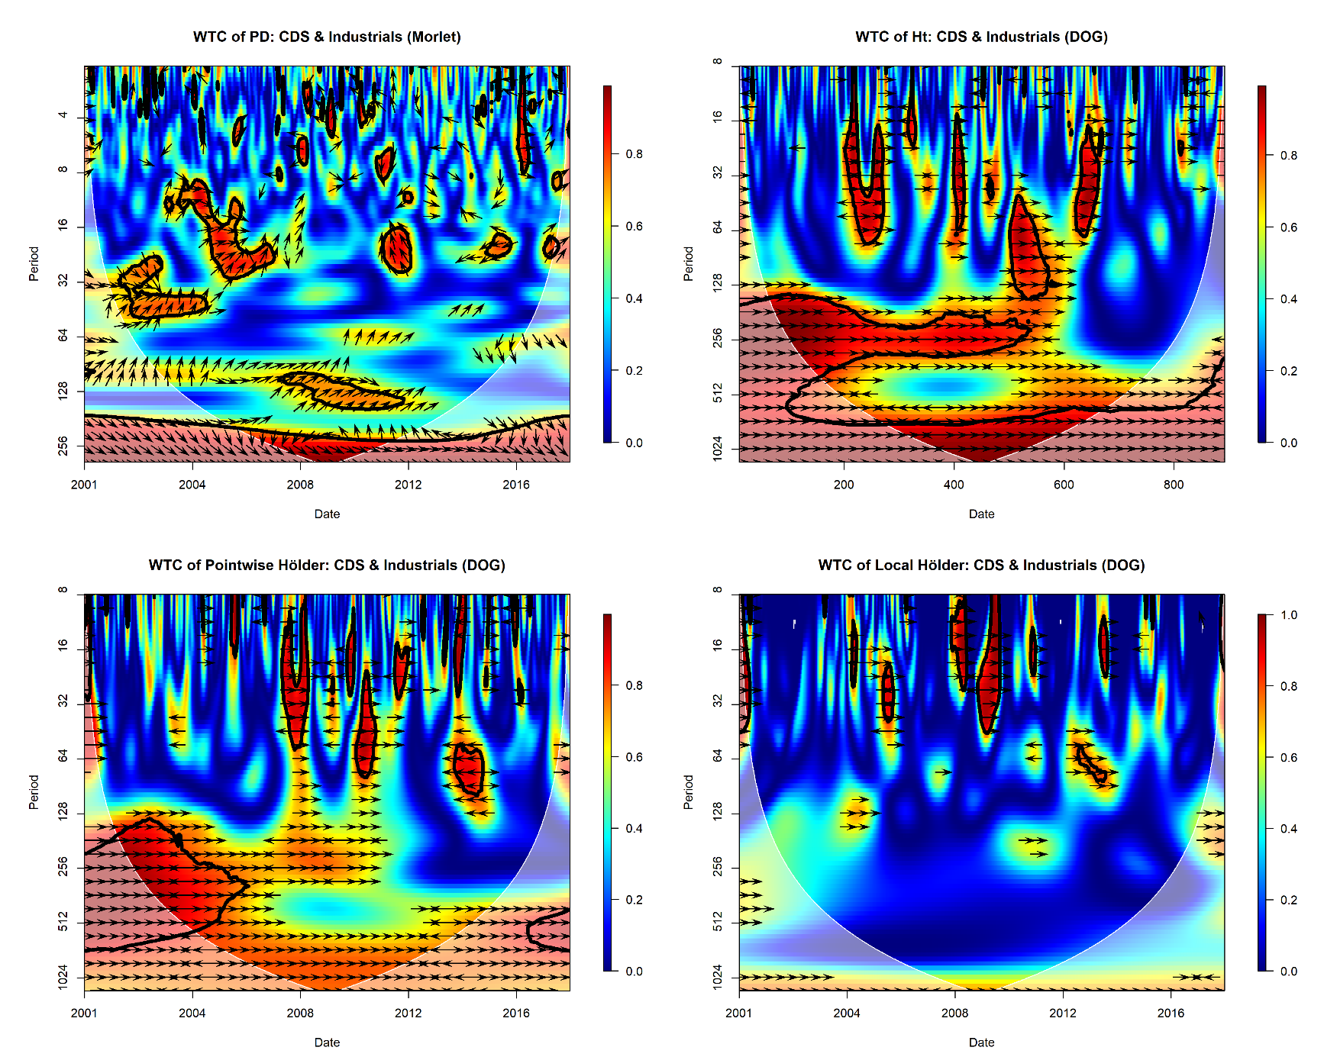
- WTC: CDS versus Industrials
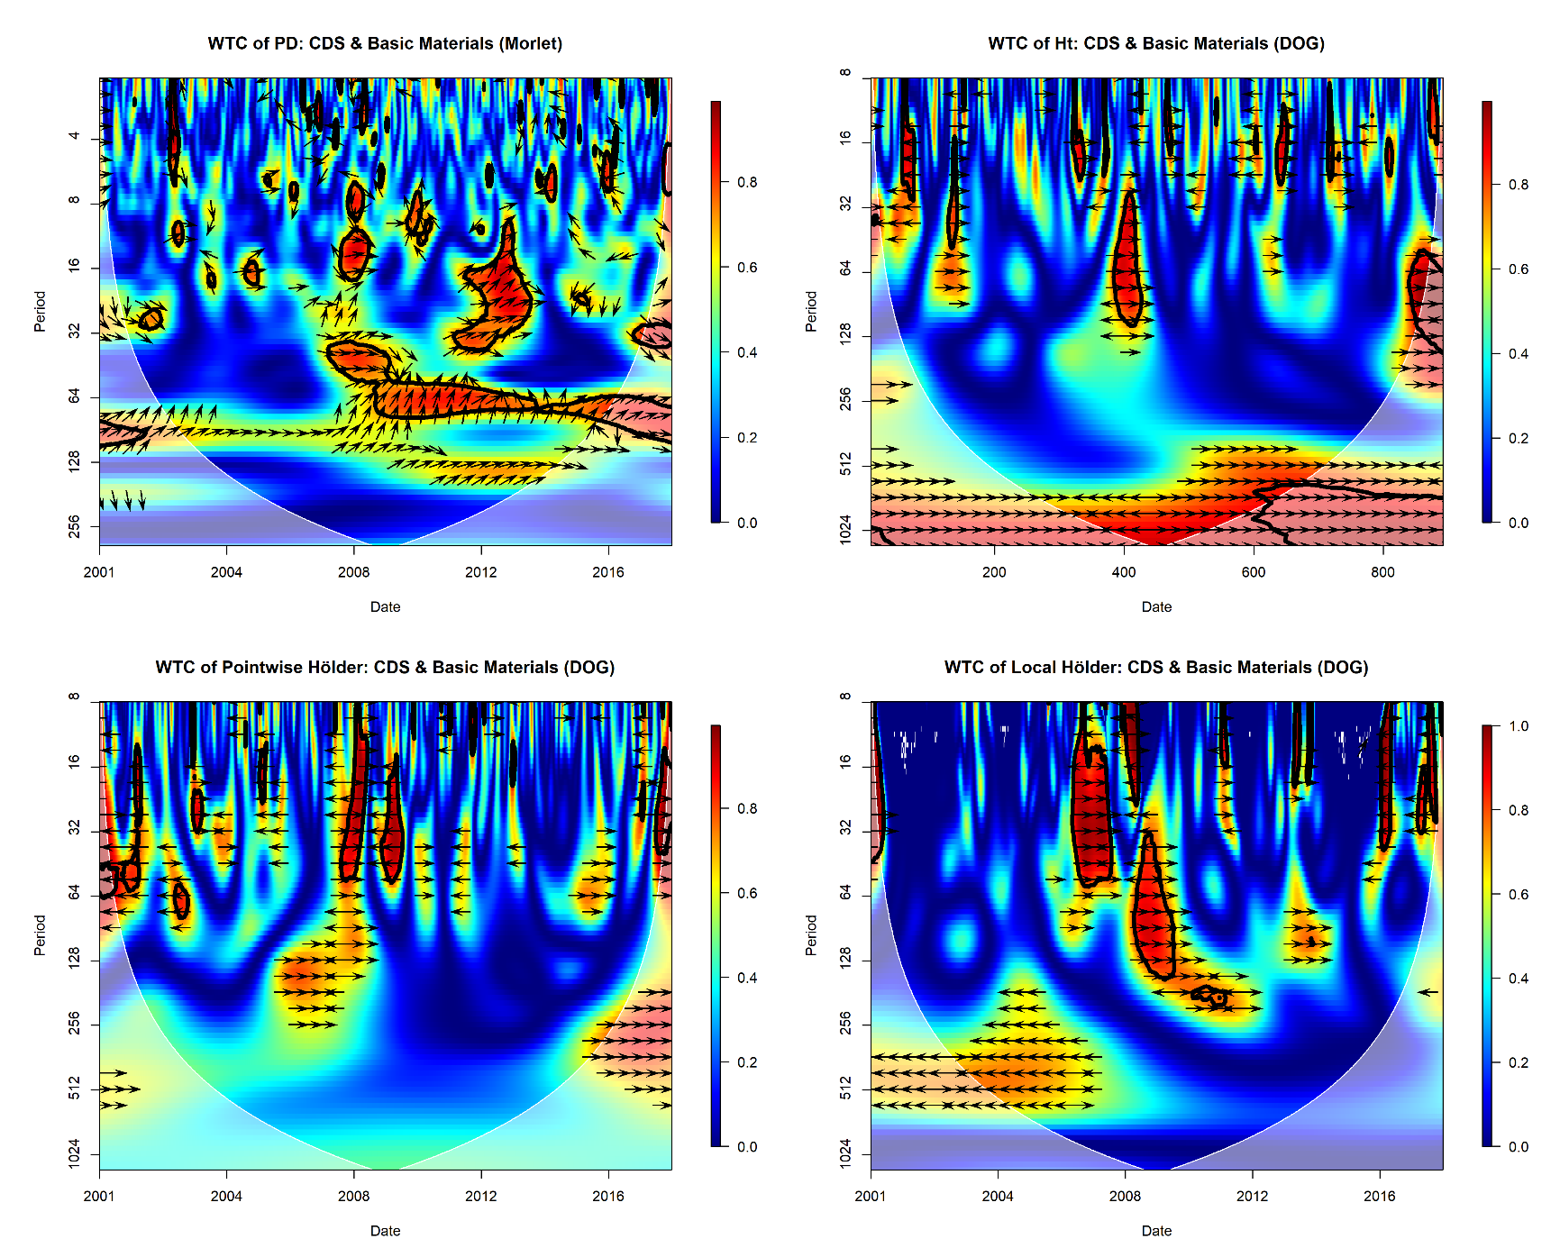
- WTC: CDS versus Basic Materials
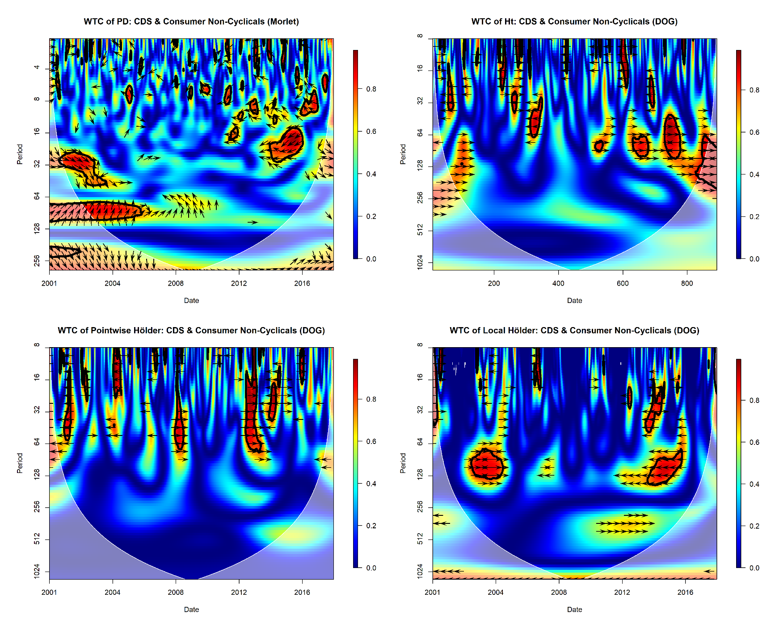
- WTC: CDS versus Consumer Non-Cyclicals
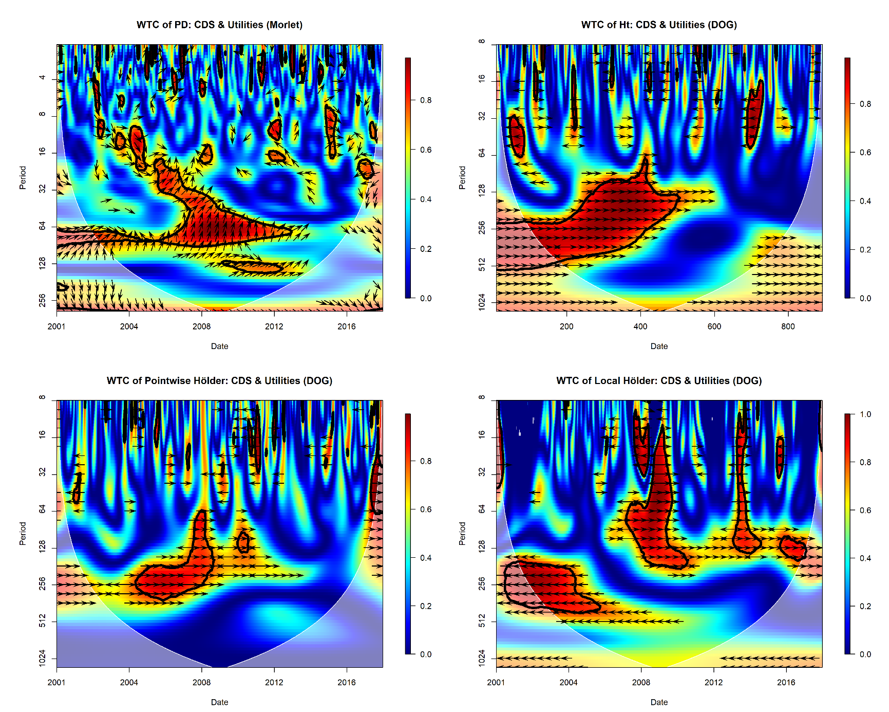
- WTC: CDS versus Utilities

Figure 2. Quadruple wavelet coherence
